**Simplified Student Enrollment System**

**Part 1: SQL Development**

**Create Tables**

Create 3 tables: Students table, Courses table, and Enrollments table

**Code:** Create 3 tables

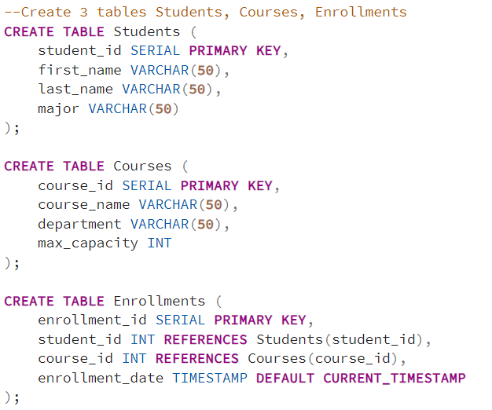

**Output**: Successful tables creation

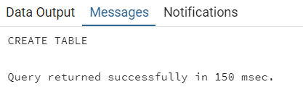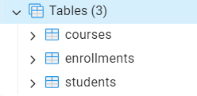

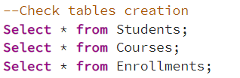

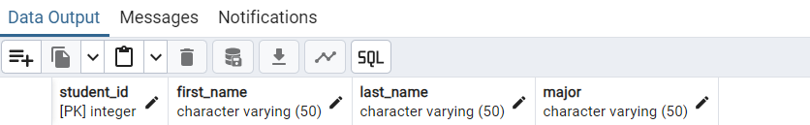

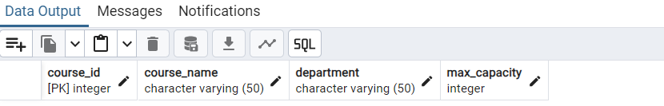

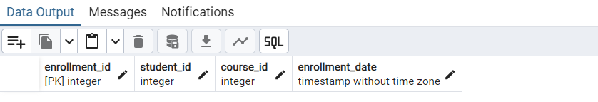

# **1.1. Create Stored Procedure for Student Enrollment**

**Code**: Create a stored procedure named EnrollStudent()

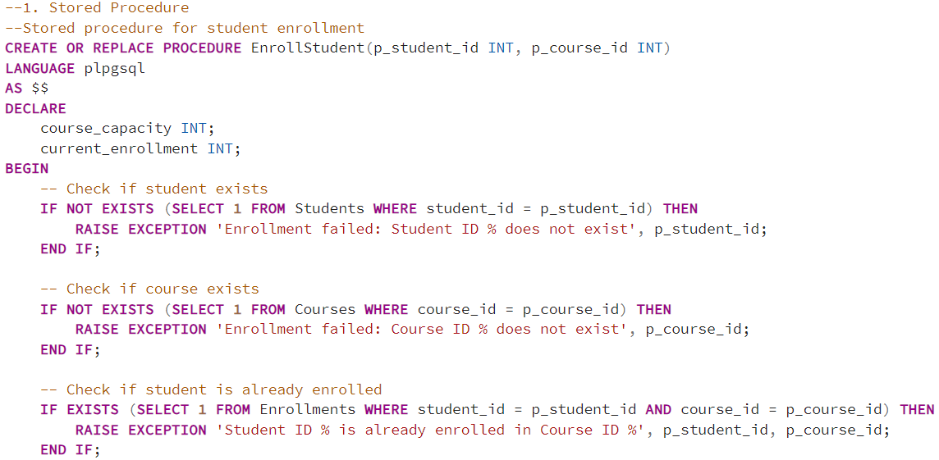

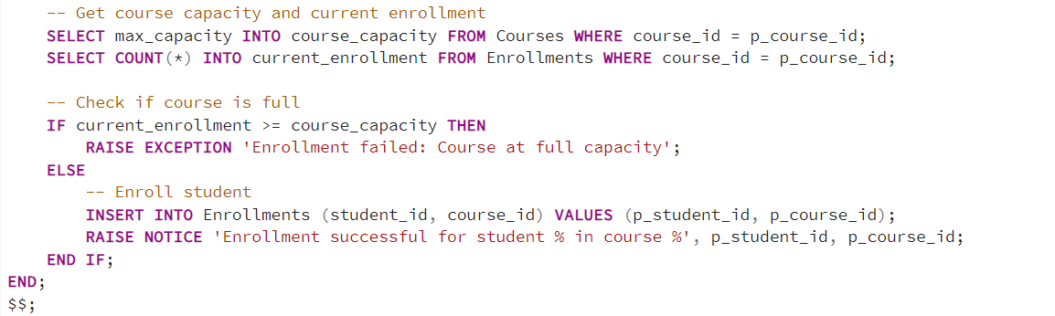

**Explanation**: In the stored procedure, checks for:

* Student existence: if not exist → raise exception that student does not exist
* Course existence
* Enrollment status: check if student is already enrolled or not
* Course capacity: check if the course is full or not
* If student does not exist and course is not full, then enroll student in course by INSERT INTO Enrollments table

**Output**: Successful creation of the stored procedure

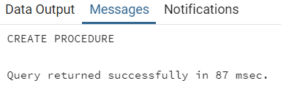

# **1.2. Create Views**

Create views for displaying enrollment and capacity information

**Student Course View**

**Code**: Create StudentCourseView that combines data from Students table, Courses table, and Enrollments table to display details like student_id, student_name, course_name, and enrollment_date.

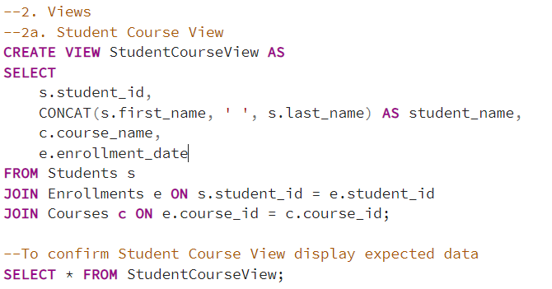

**Output**: StudentCourseView successful creation

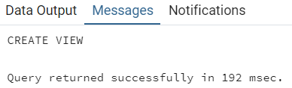





**Course capacity View**

**Code**: CourseCapacityView creation

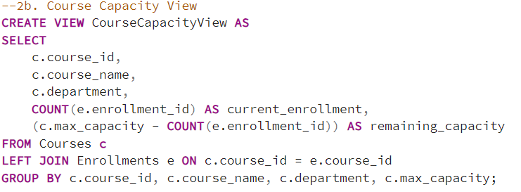

**Output**: CourseCapacityView successful creation

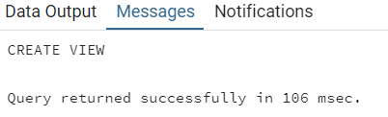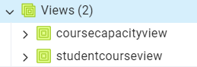





# **1.3. Create Triggers**

## **Trigger to Update Capacity**

**Code**: Create trigger to update capacity

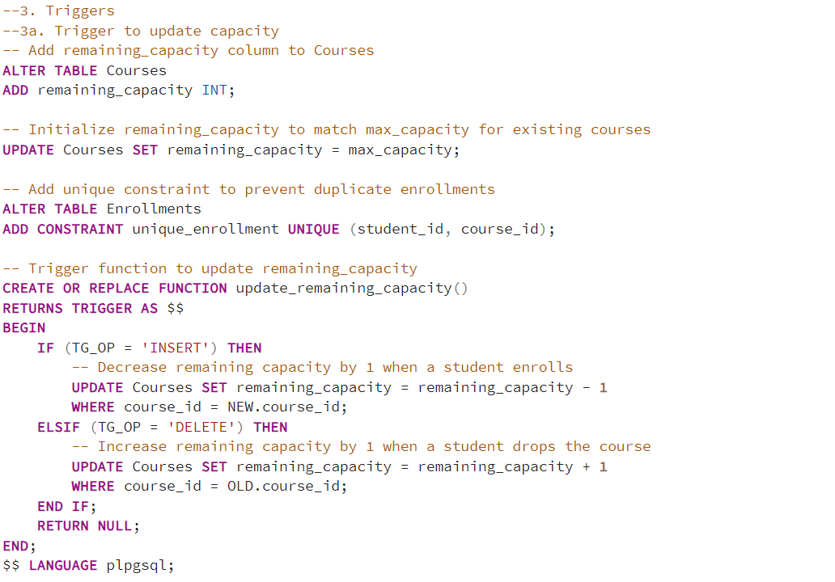

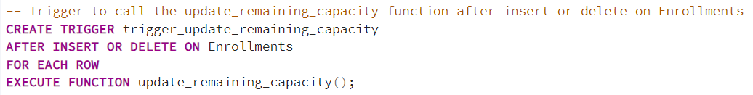

**Explanation**:

* Step 1: Add a new column remaining_capacity to the Courses table, which will keep track of how many spots are still available in each course.
* Step 2: Set remaining_capacity equal to max_capacity for all existing courses, making sure remaining_capacity starts with the correct value.
* Step 3: Add unique constraint to ensure that each student can enroll in each course only once, preventing duplicate enrollment records
* Step 4: Create a function update_remaining_capacity() to adjust the max_capacity of a course based on enrollments.
  + If a new row is inserted into Enrollments table (a student enrolls), it decreases remaining_capacity by 1 for the associated course_id.
  + If a row is deleted from Enrollments table(a student withdraws), it increases remaining_capacity by 1 for that course_id.
* Step 5: Create trigger trigger_update_remaining_capacity(): This trigger is activated after every INSERT or DELETE operation on the Enrollments table, ensuring that any changes to enrollments are immediately reflected in the course's max_capacity .

**Output**: Trigger successful creation

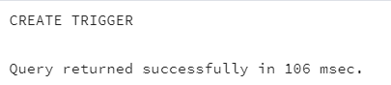

## **Trigger to Log Enrollment Events**

**Code**: Create trigger to log enrollment events

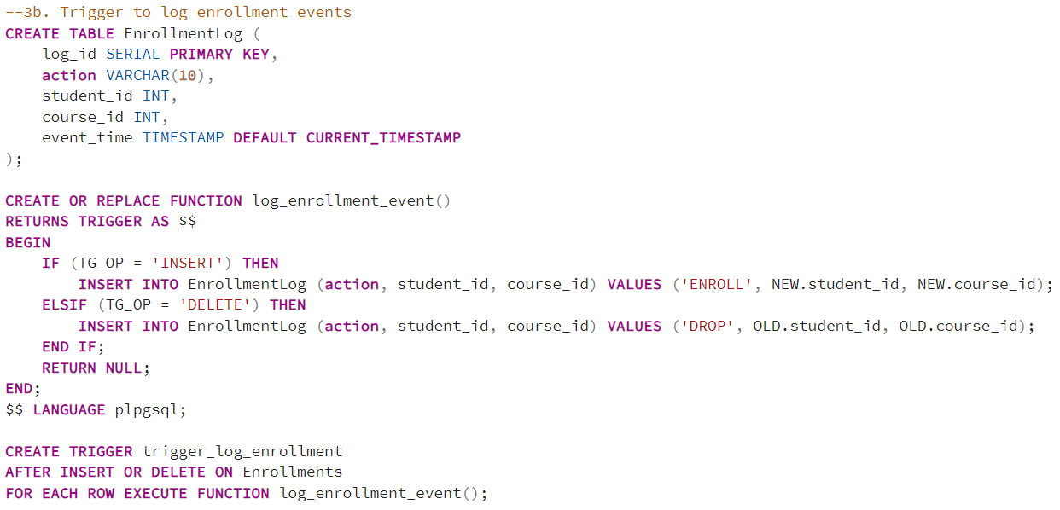

**Explanation**:

* Step 1: Create Enrollmentlog table to store log entries with a unique log_id, action type (either 'ENROLL' or 'DROP'), student_id, course_id, and a timestamp (event_time) of the action.
* Step 2: Create function log_enrollment_event() to detect actions on the Enrollments table:
  + If a student enrolls (INSERT), it logs the action as 'ENROLL' with student_id and course_id.
  + If a student withdraws (DELETE), it logs the action as 'DROP'.
* Step 3: Create trigger trigger_log_enrollment. This trigger runs after any INSERT or DELETE on Enrollments, automatically calling log_enrollment_event to record each action.

**Output**: Successful creation of 2 triggers

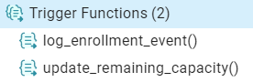

**Part 2: Python Integration**

# **Database Connection and Connection Test**

**Explanation**:

* The connect_db() function establishes a connection to the PostgreSQL database using psycopg2 and returns a connection object.
* The test_connection() function uses this connection to run a simple query, ensuring that the database is accessible.

These functions verify database accessibility before further operations. test_connection() confirms a successful connection with a basic date query.

**Code**:



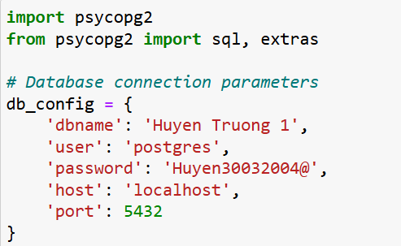

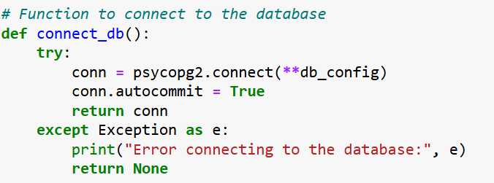

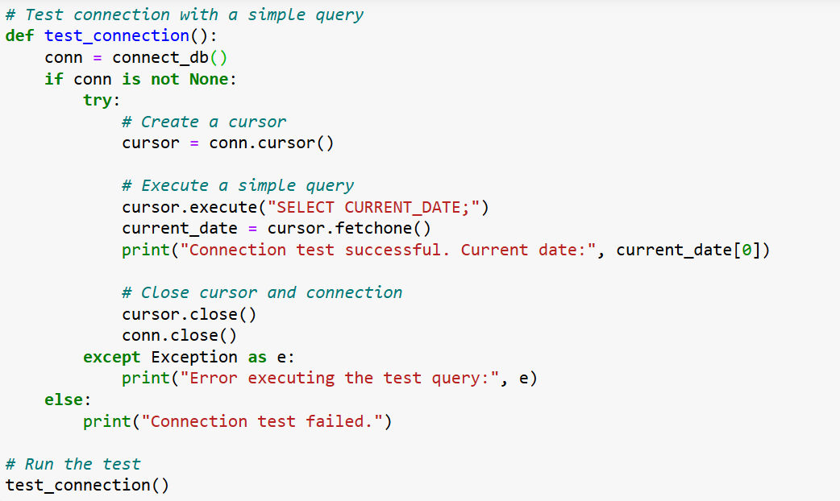

# **Calling the Stored Procedure**

**Explanation**:

* The function enroll_student() takes student_id and course_id as input parameters, calling the stored procedure EnrollStudent in the database by using the CALL statement.
* The function handles exceptions for situations like a full course or a duplicate enrollment.

**Code**:

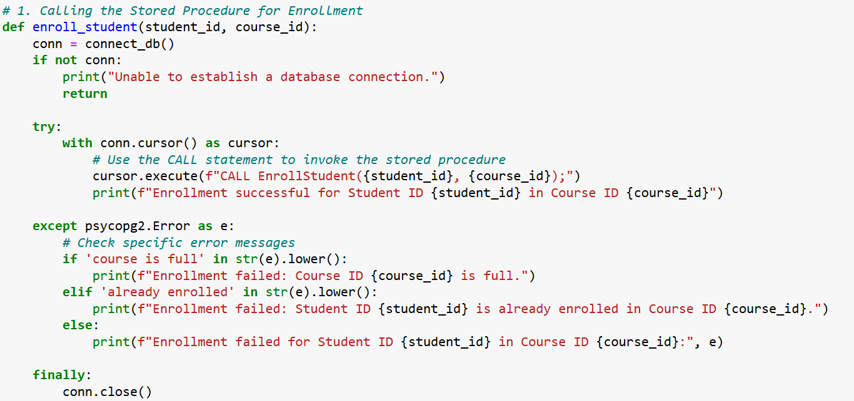

# **Querying the Views:**

**Explanation:**

* query_student_course_view()retrieves data from StudentCourseView to display each student’s enrollment details.
* query_course_capacity_view()retrieves data from CourseCapacityView to show the course capacity and current enrollment.

Both functions use the tabulate library to improve readability of the output.

**Query the Student Course View**

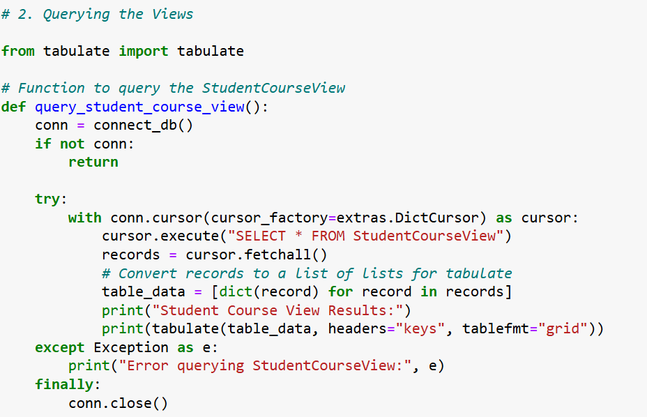

**Query the Course Capacity View**

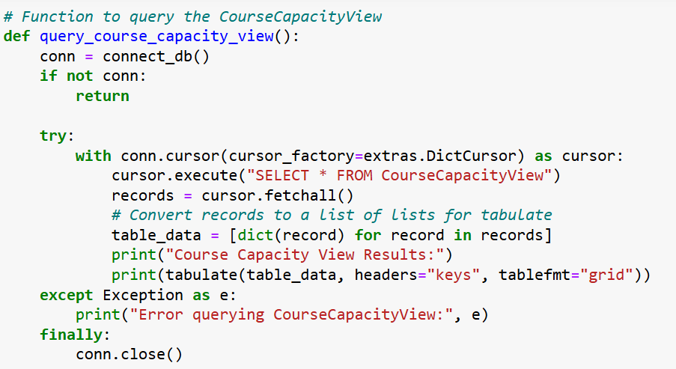

# **Trigger events**

**Explanation:**

* test_trigger_insert() inserts a new enrollment record, triggering any associated database actions like updating course capacity and logging.
* test_trigger_delete() removes an enrollment, triggering updates in course capacity and logging if such triggers exist.

**Code:**

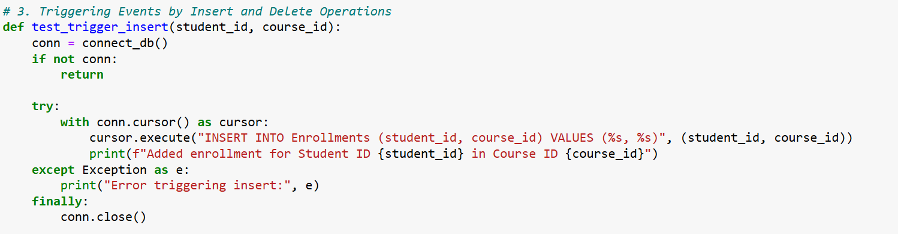

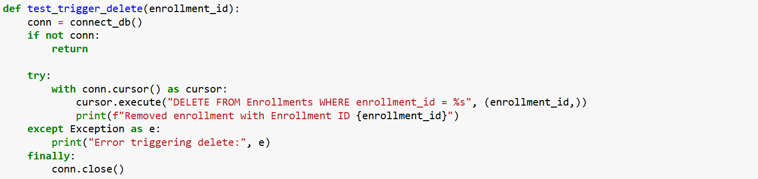

The test results and outcomes for the triggers are detailed in the test cases section below.

**Test Plans**

# **Populate data**

Populate 2 tables Students table and Courses table with data in SQL code:

Since the Students table defines student_id as SERIAL and the Courses table defines course_id as SERIAL, unique integer IDs are automatically generated for each student and course upon data insertion. Therefore, only the relevant column information was provided when populating the tables.

**Code**: Insert data into Students table:

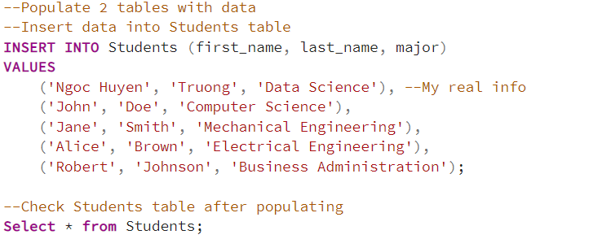

**Output**: Students table after inserting data

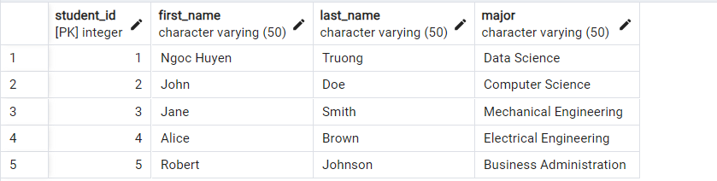

**Code**: Insert data into Courses table:

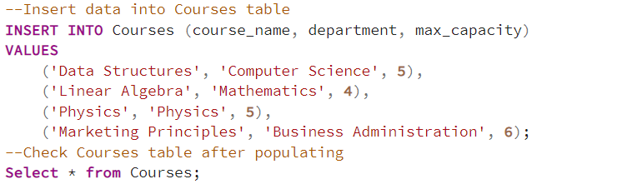

**Output**: Courses table after inserting data

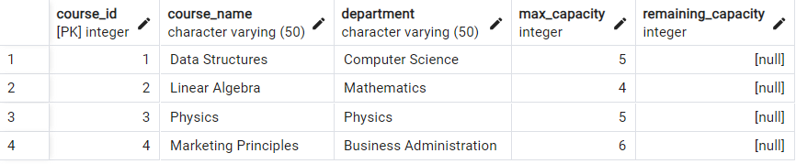

For now, leave the Enrollments table empty, as it will be populated during the stored procedure tests.

**Review 2 tables Students and Courses in Python**

Students table:

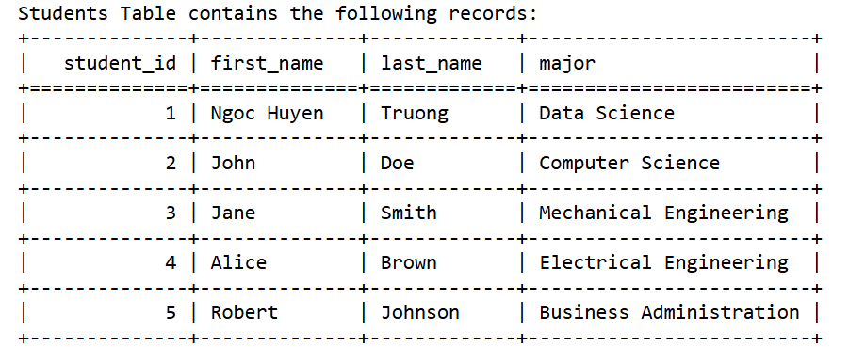

Courses table:

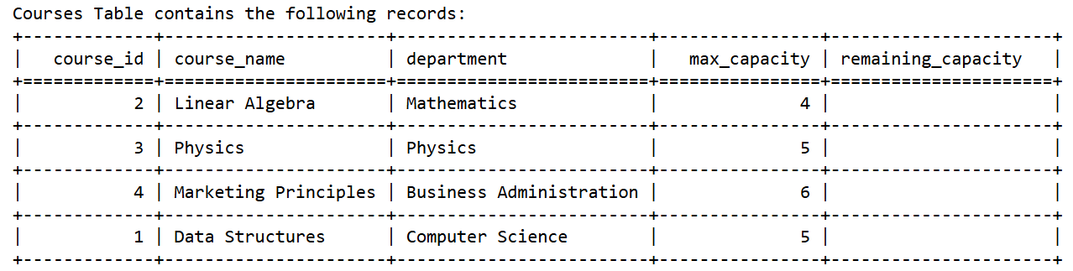Before proceeding with the test cases, I created two functions:

* **Function to query the Enrollments table**: This function checks the Enrollments table to verify if a student has been successfully enrolled in a course.
* **Function to query the EnrollmentLog table**: This function queries the EnrollmentLog table to ensure that an enrollment record was added when the student enrolls or drops a course.

**1. Function to query the Enrollments table** 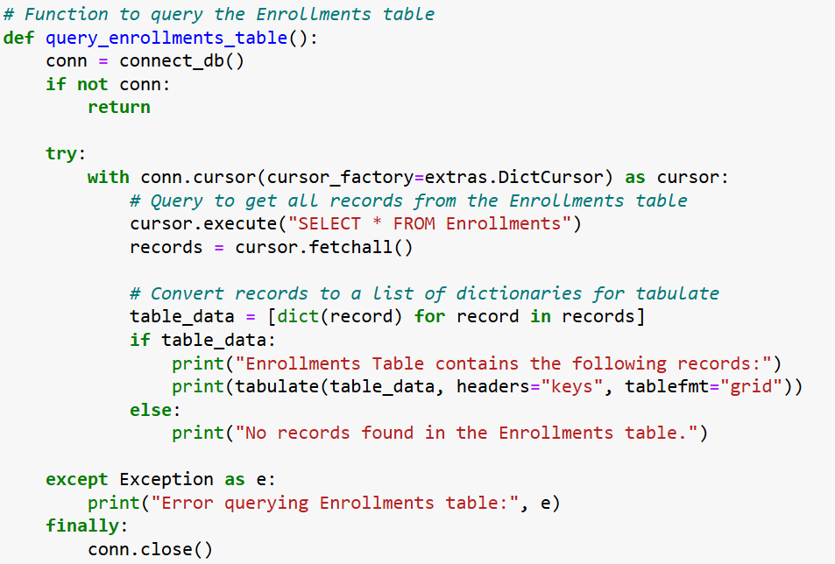

**2. Function to query the EnrollmentLog table** 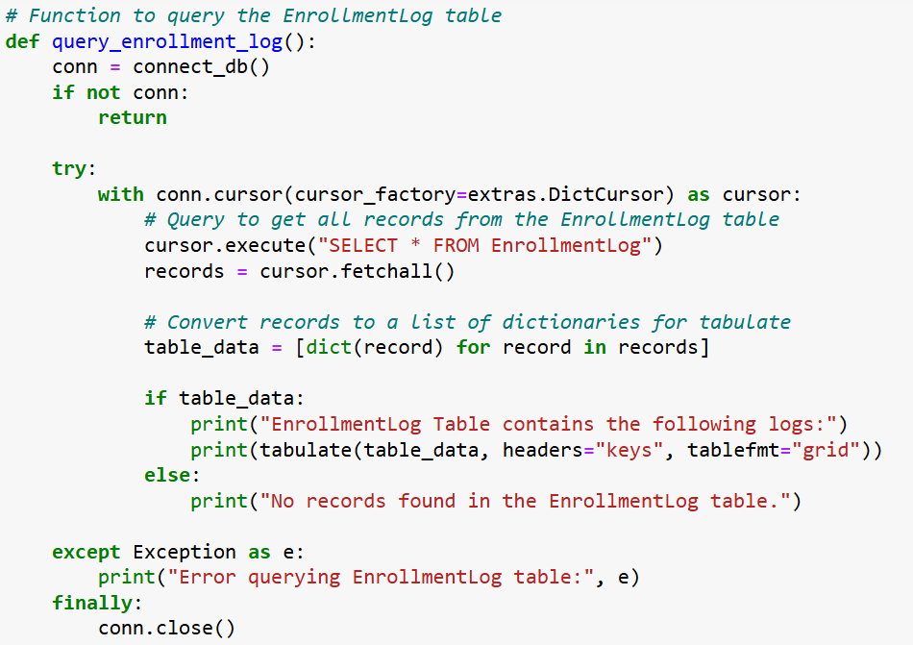

# **Test Plan: University Enrollment System**

|  |
| --- |
| **Test Plan: University Enrollment System** **Test Case 0: Successful Enrollment (Sample test)** **Objective**: Ensure that a student can be successfully enrolled in a course when the course has available capacity and the student is not already enrolled.  · **Preconditions**:  1. Students table has a student with student_id = 1 (Ngoc Huyen Truong).  2. Courses table has a course with course_id = 1 (Data Structures) and max_capacity = 5.  3. There are currently fewer than 5 students enrolled in course 1.  · **Steps**:  1. Execute the EnrollStudent(1, 1) stored procedure from the Python script.  2. Query the Enrollments table to check if the record has been inserted.  3. Query the StudentCourseView to confirm the enrollment.  4. Query the CourseCapacityView to ensure the remaining capacity is reduced by 1.  · **Expected Results**:  1. Enrollments table has a new record for student_id = 1 and course_id = 1.  2. StudentCourseView displays the student and course with the correct enrollment_date.  3. CourseCapacityView shows the remaining_capacity decreased by 1.  4. The EnrollmentLog table logs the enrollment event with the action ENROLL. |

**Code**:

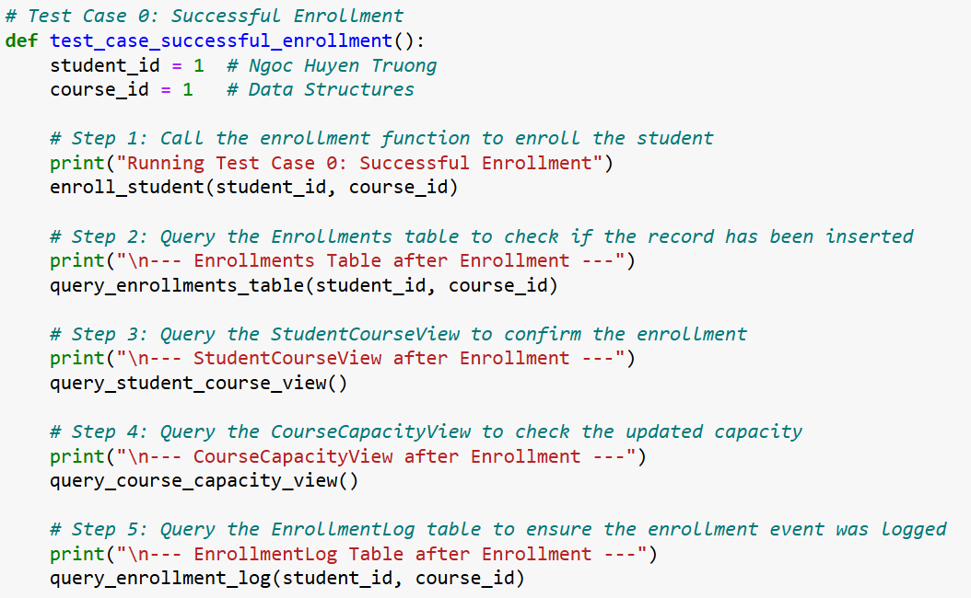**Output**:

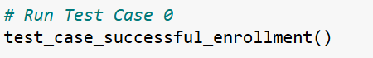

1. Enrollments table has a new record for student_id = 1 and course_id = 1.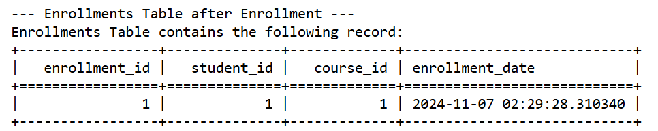
2. StudentCourseView displays the student and course with the correct enrollment_date.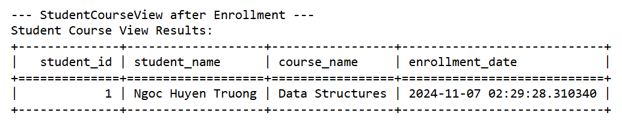
3. CourseCapacityView shows the remaining_capacity decreased by 1. After enrolling the student with student_id = 1 in the Data Structures course, which has a maximum capacity of 5, the CourseCapacityView was checked to verify the enrollment impact. The view now reflects an updated current_enrollment = 1 and remaining_capacity = 4, confirming that the enrollment was processed correctly and the capacity has been decreased by 1 as expected.

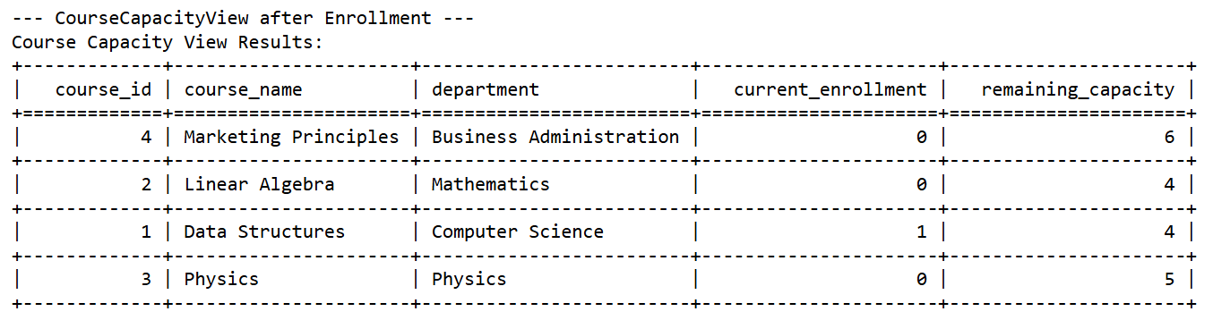

4. The EnrollmentLog table logs the enrollment event with the action ENROLL 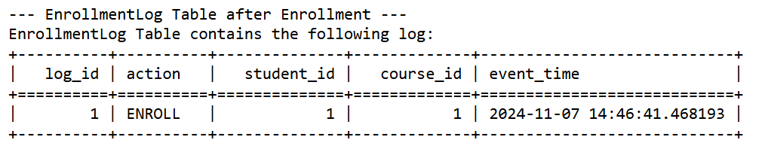

|  |
| --- |
| **Test Plan: University Enrollment System** **Test Case 1: Course Capacity Update After Multiple Enrollments** **Objective**: Confirm that the system accurately updates the remaining course capacity as students enroll.  · **Preconditions**:  1. Course course_id = 4 (e.g., Marketing Principles) has a max capacity of 6.  2. Multiple students are not yet enrolled in course_id = 4.  · **Steps**:  1. Enroll three students (e.g., student_id = 1, student_id = 2, and student_id = 3) in course_id = 4 one by one by executing the EnrollStudent() stored procedure from the Python script.  2. Query the CourseCapacityView after each enrollment to confirm remaining capacity decreases by 1 each time.  · **Expected Results**:  1. Enrollments table has a new record for 3 students student_id = 1,student_id = 2, and student_id = 3 in course_id = 4.  2. After each enrollment, CourseCapacityView reflects the adjusted remaining capacity. |

**Code**:

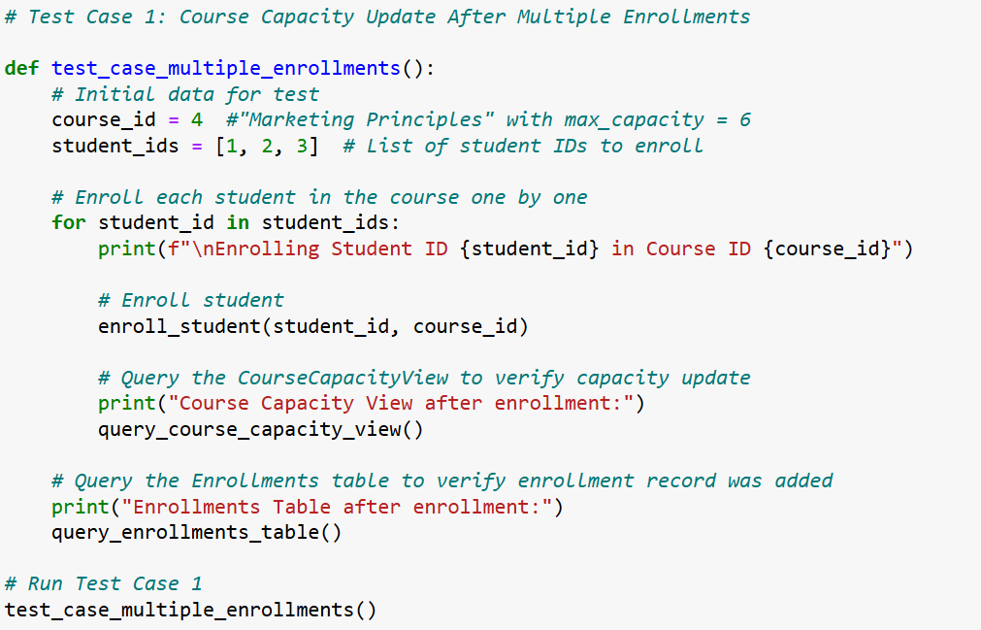

**Output:**

1. Enrollments table has a new record for 3 students student_id = 1,student_id = 2, and student_id = 3 in course_id = 4. 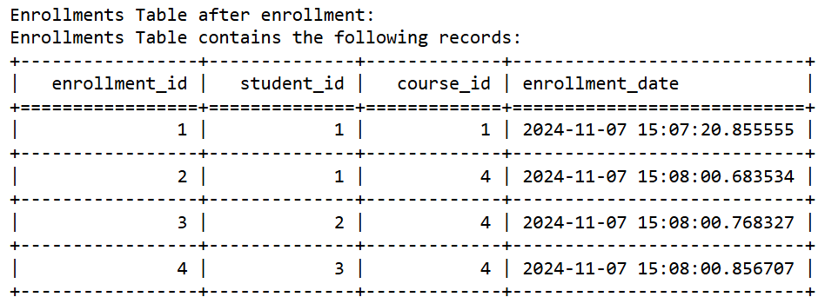
2. After each enrollment, CourseCapacityView reflects the adjusted remaining capacity. For student_id = 1 in course_id = 4 (max capacity = 6), after successful enrollment, current_emrollment = 1 and remaining_capacity = 5.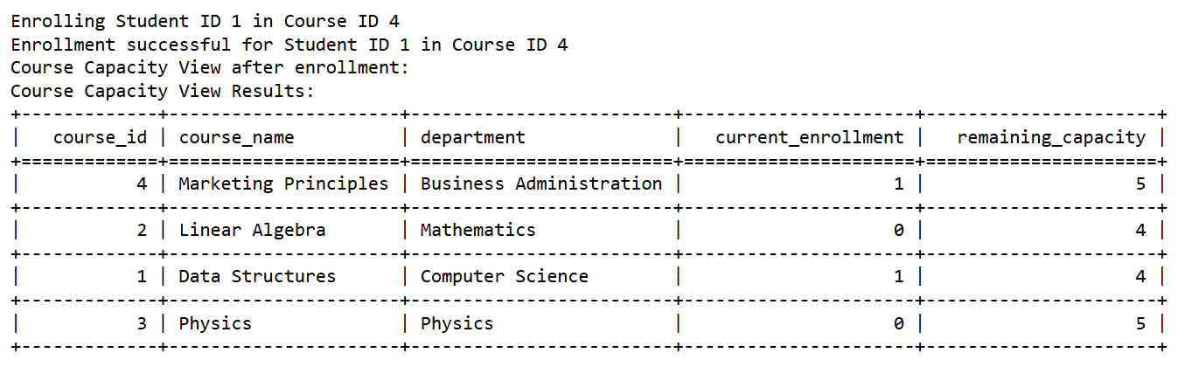For student_id = 2 in course_id = 4 (max capacity = 6), after successful enrollment, current_emrollment = 2 and remaining_capacity = 4.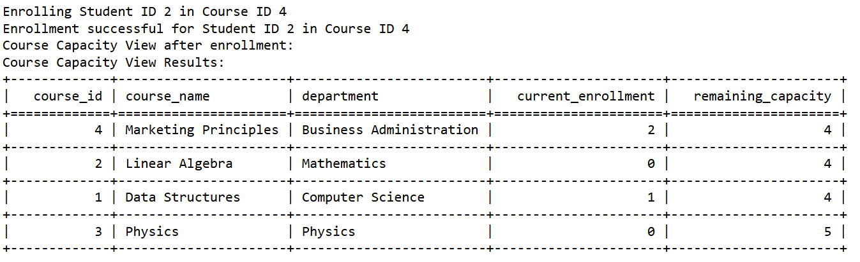For student_id = 3 in course_id = 4 (max capacity = 6), after successful enrollment, current_emrollment = 3 and remaining_capacity = 3.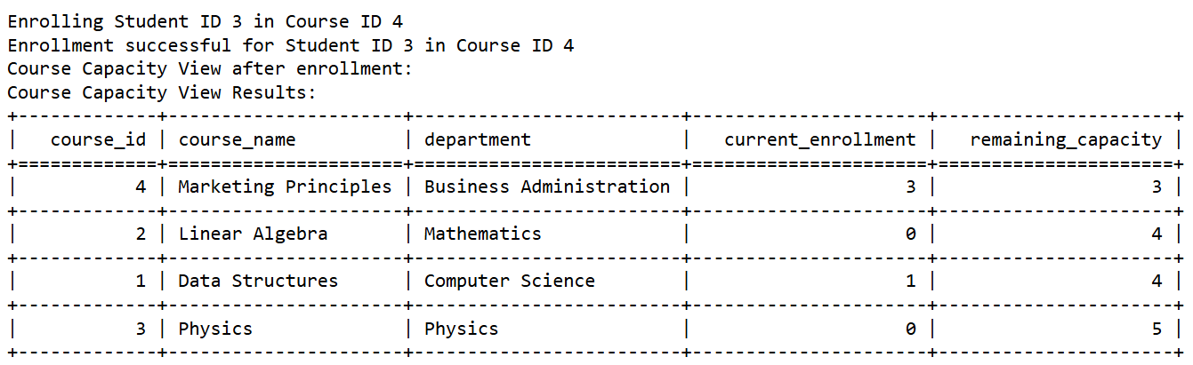

|  |
| --- |
| **Test Plan: University Enrollment System** **Test Case 2: Event Logging for Enrollment** **Objective**: Verify that each enrollment action is logged in the EnrollmentLog table.  · **Preconditions**:  1. Students table has a student with student_id = 4 (Alice Brown).  2. Courses table has a course with course_id = 3 (Physics).  3. Student with student_id = 4 is not yet enrolled in course_id = 3.  · **Steps**:  1. Execute the EnrollStudent(4, 3) stored procedure from the Python script.  2. Query the EnrollmentLog table to check if the action was logged with action = ENROLL.  3. Query the StudentCourseView to confirm the enrollment.  4. Query the CourseCapacityView to ensure the remaining capacity is reduced by 1.  · **Expected Results**:  1. Enrollments table has a new record for student_id = 4 and course_id = 3.  2. StudentCourseView displays the student and course with the correct enrollment_date.  3. CourseCapacityView shows the remaining_capacity decreased by 1.  4. The EnrollmentLog table logs the enrollment event with the action ENROLL. |

**Code:**

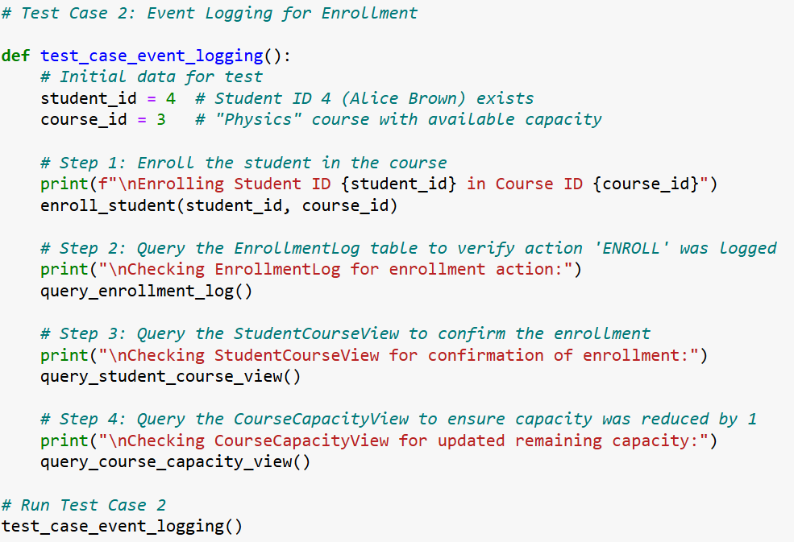

**Output**:

1. The EnrollmentLog table logs the enrollment event with the action ENROLL.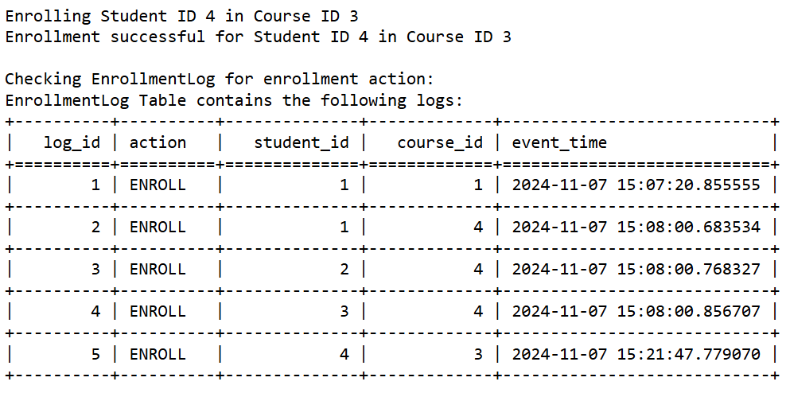
2. StudentCourseView displays the student and course with the correct enrollment_date. The view shows that student_id = 4 (Alice Brown) is enrolled course_id = 3 (Physics)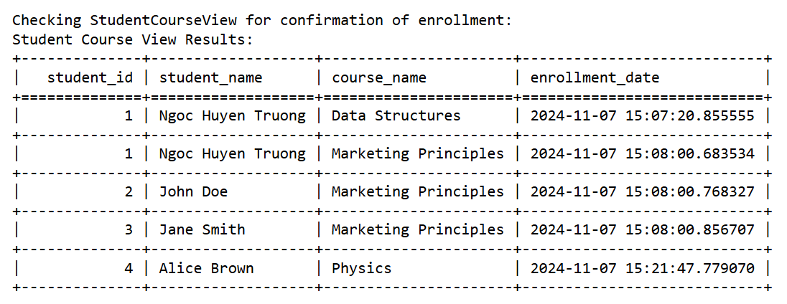
3. CourseCapacityView shows the remaining_capacity of the Physics course decreased by 1.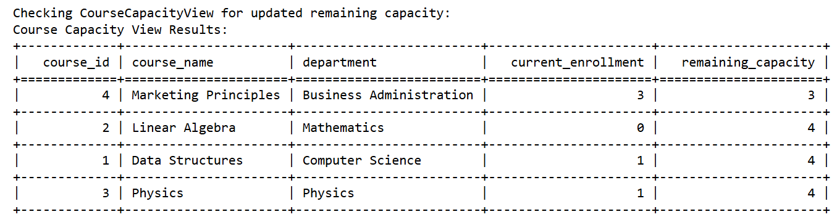

|  |
| --- |
| **Test Plan: University Enrollment System** **Test Case 3: Double Enrollment Prevention** **Objective**: Ensure that a student cannot enroll in the same course twice.  · **Preconditions**:  1. Students table has a student with student_id = 4 (Alice Brown).  2. Courses table has a course with course_id = 3 (Physics).  3. Student with student_id = 4 is already enrolled in course_id = 3.  · **Steps**:  1. Execute the EnrollStudent(4, 3) stored procedure from the Python script to try enrolling this student again.  2. Query the Enrollments table to verify no duplicate enrollment.  3. Verify that the EnrollmentLog table logs the "already enrolled" status.  · **Expected Results**:  1. Enrollment fails, and a message "Enrollment failed: Student ID 4 is already enrolled in Course ID 3" is displayed.  2. No duplicate record is added to the Enrollments table.  3. The EnrollmentLog table has no added action. |

**Code**: Precondition: student_id = 4 is already enrolled in course_id = 3

The last row in the Enrollments table shows that a student with student_id = 4 is already enrolled in course_id = 3.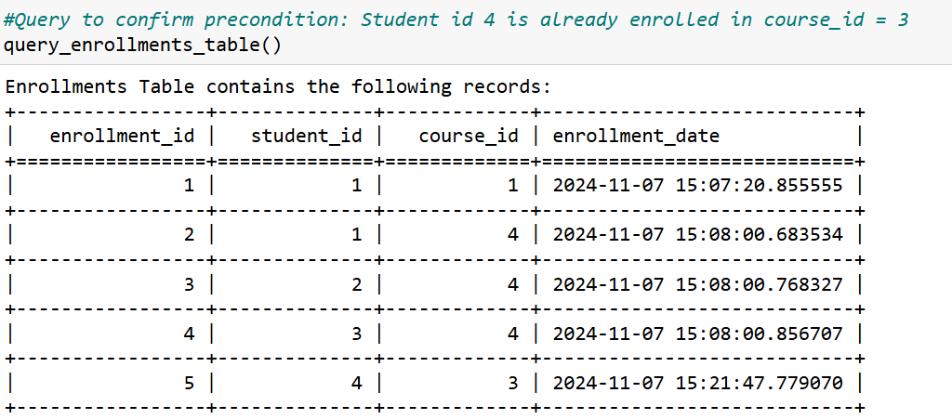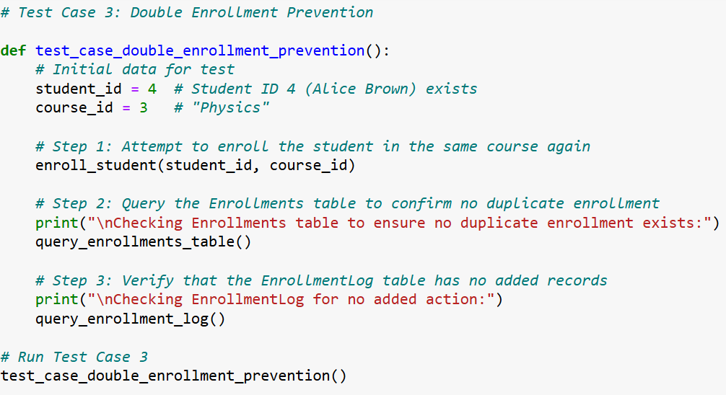

**Output**:

1. Enrollment fails, and a message "Enrollment failed: Student ID 4 is already enrolled in Course ID 3" is displayed. 
2. No duplicate record is added to the Enrollments table. There is only 1 enrollment for student_id = 4 in course_id = 3.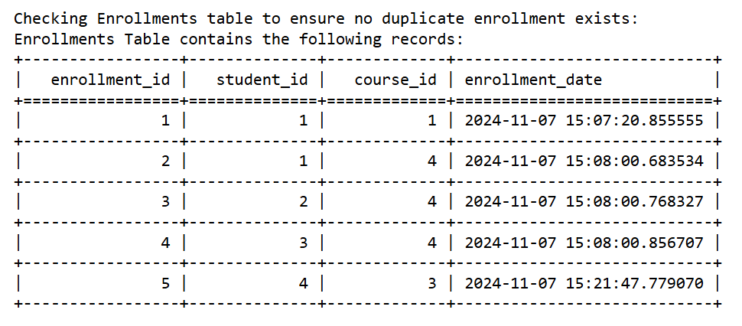
3. The EnrollmentLog table has no added action compared to previous test case 2.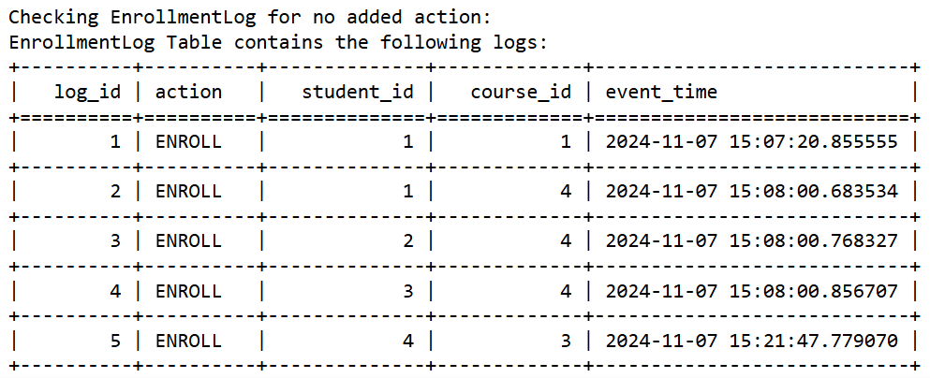

|  |
| --- |
| **Test Plan: University Enrollment System** **Test Case 4: Successful Unenrollment** **Objective**: Verify that a student can successfully unenroll from a course and the system updates capacity accordingly.  · **Preconditions**:  1. Enrollments table exists of a student with student_id = 4 in course_id = 3.  2. CourseCapacityView shows current capacity data.  · **Steps**:  1. Remove the enrollment for student_id = 4 in course_id = 3 using test_trigger_delete().  2. Query the CourseCapacityView to ensure the remaining capacity increased by 1.  3. Verify that EnrollmentLog records the DROP action.  · **Expected Results**:  1. Enrollments table now does not have the record for student_id = 4 and course_id = 3.  2. CourseCapacityView shows the remaining_capacity increased by 1.  3. The EnrollmentLog table logs the unenrollment event with the action DROP. |

**Code**: Precondition: Enrollments table exists of a student with student_id = 4 in course_id = 3.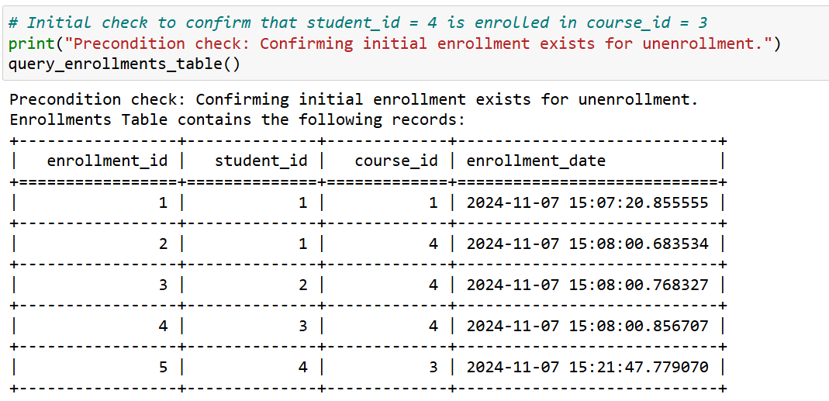

**Output:**

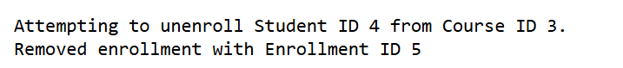

1. Enrollments table now does not have the record for student_id = 4 and course_id = 3 (enrollment_id = 5).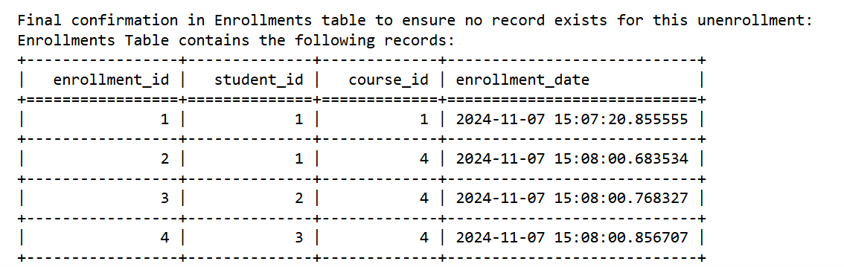
2. CourseCapacityView shows the remaining_capacity increased by 1. The current_enrollment of Physics course is back to 0 and remaining_capacity = 5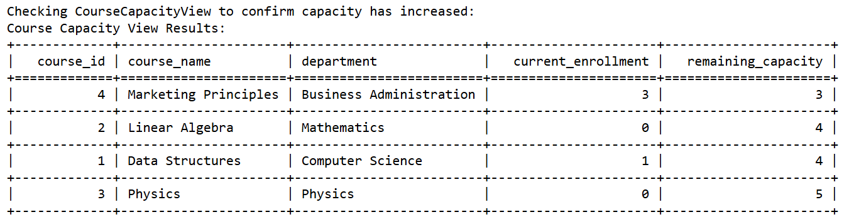
3. The EnrollmentLog table logs the unenrollment event with the action DROP.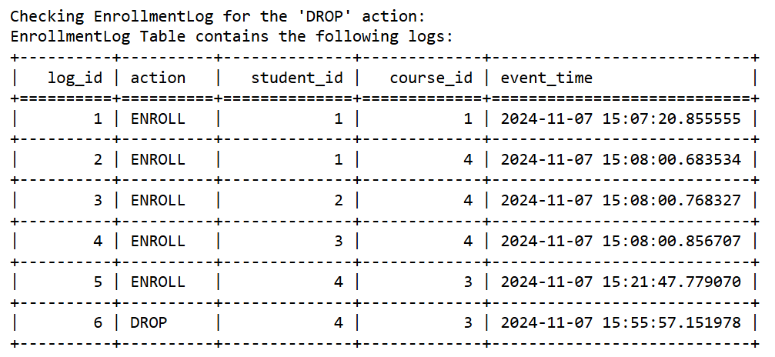

|  |
| --- |
| **Test Plan: University Enrollment System** **Test Case 5: Full Course Enrollment** **Objective**: Verify that the system prevents a student from enrolling in a course that has reached its maximum capacity.  · **Preconditions**:  1. Students table has a student with student_id = 5 (Robert Johnson).  2. Courses table has a course with course_id = 2 and max_capacity = 4.  3. Currently, 4 students are enrolled in course 2.  · **Steps**:  1. Execute the EnrollStudent(5, 2) stored procedure from the Python script.  2. Query the Enrollments table to check if the enrollment failed.  3. Verify no change in the CourseCapacityView.  · **Expected Results**:  1. Enrollment fails, and a message "Enrollment failed: Course ID 2 is full." is displayed.  2. Enrollments table remains unchanged for this student and course.  3. CourseCapacityView shows no change in the remaining capacity. |

**Code**: Data preparation: Enroll students with ID 1, 2, 3, 4 into course_id = 4 so that the course_id = 4 (Linear Algebra) reaches the max_capacity = 4.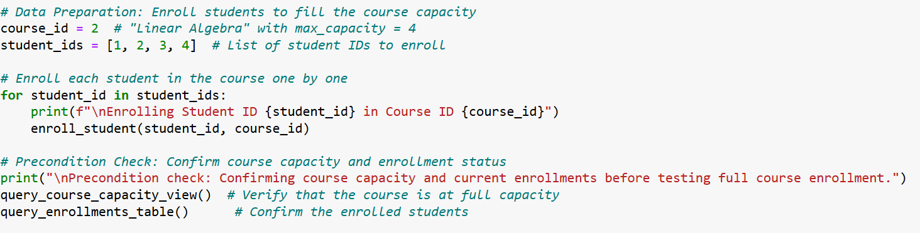**Precondition**: Currently, 4 students are enrolled in course 2 (Linear Algebra), the course is at full capacity.

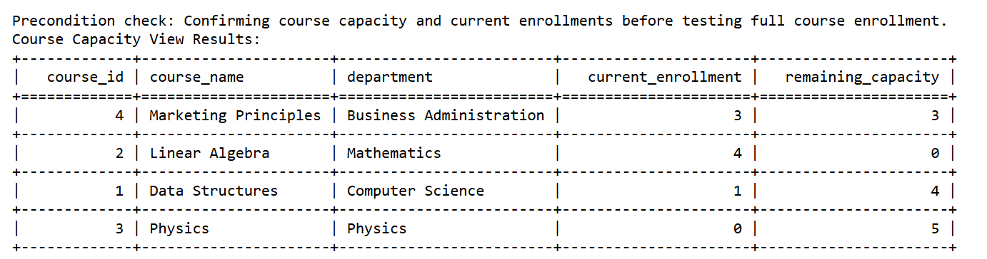The Enrollments tables now has 9 enrollments: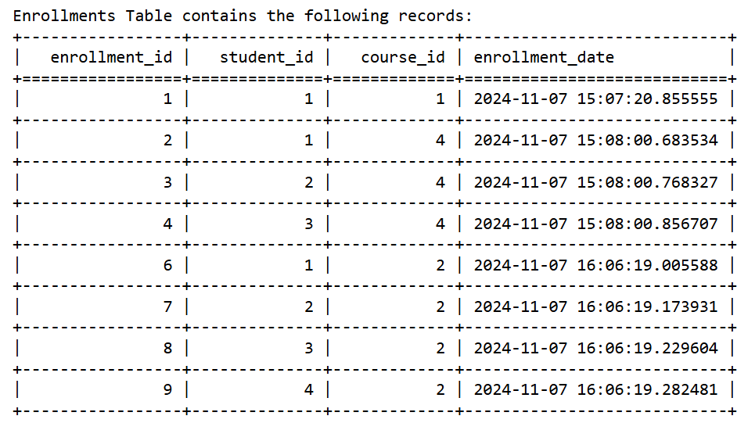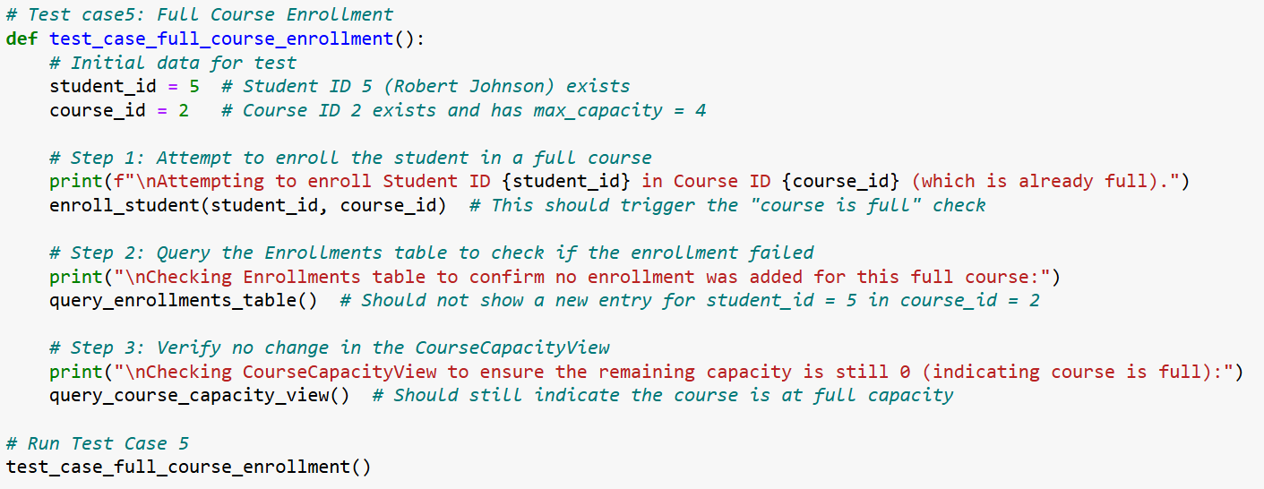**Output**:

1. Enrollment fails, and a message "Enrollment failed for Student ID 5 in Course ID 2: Course at full capacity." is displayed. 
2. Enrollments table remains unchanged for this student and course (still having 9 enrollments)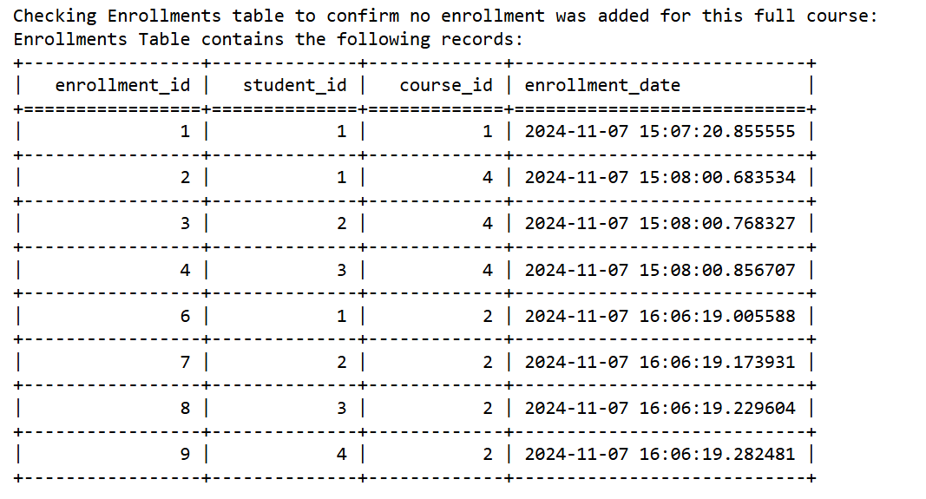
3. CourseCapacityView shows no change in the remaining capacity, still 0 indicating the course is full. 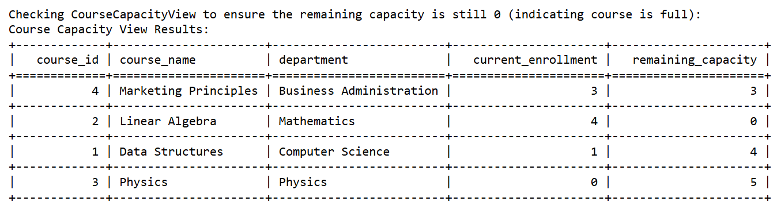

|  |
| --- |
| **Test Plan: University Enrollment System** **Test Case 6: Prevent Enrollment If Student ID Does Not Exist** **Objective**: Verify that an enrollment attempt fails if the student does not exist in the **Students** table.  · **Preconditions**:  1. course_id = 4 exists in the Courses table (Marketing Principles).  2. There is no record in the Students table for student_id = 999.  · **Steps**:  1. Execute the EnrollStudent(999, 4) to attempt enrolling a non-existent student in course_id = 4.  2. Catch any exception and check the error message.  3. Query the Enrollments table to confirm no new entry in the **Enrollments** table for student_id = 999 and course_id = 4.  · **Expected Results**:  1. Enrollment fails, and a message "Enrollment failed: Student ID 999 does not exist." is displayed.  2. Enrollments table remains unchanged, with no entries for student_id = 999 and course_id = 4. |

**Code:**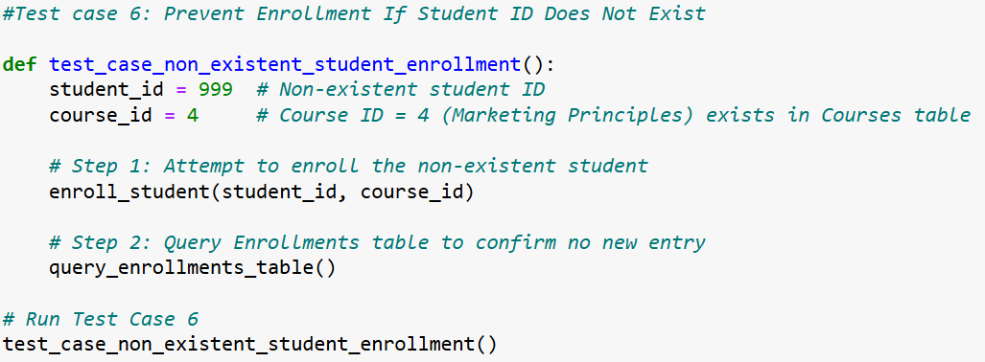

**Output**:

1. Enrollment fails, and a message "Enrollment failed: Student ID 999 does not exist." is displayed. 
2. Enrollments table remains unchanged, with no entries for student_id = 999 and course_id = 4.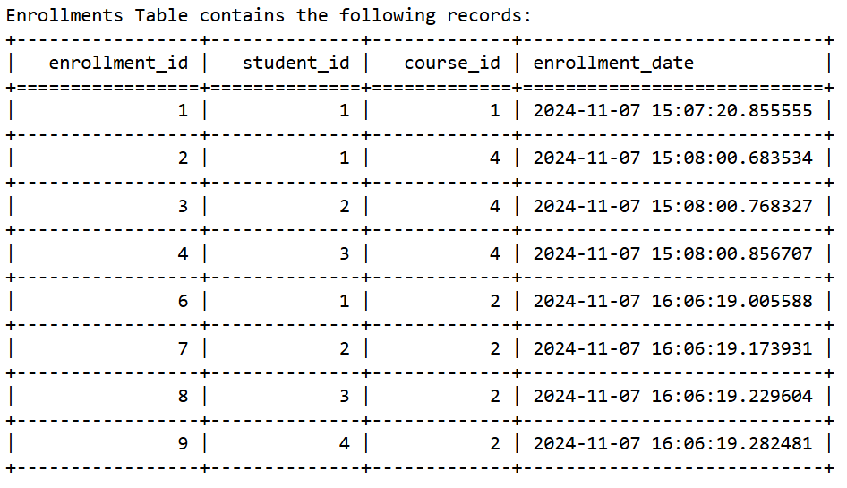

|  |
| --- |
| **Test Plan: University Enrollment System** **Test Case 7: Attempt to Enroll Student in a Non-Existent Course** **Objective**: Ensure that enrollment fails when a student tries to enroll in a course that does not exist.  · **Preconditions**:  1. The Students table contains a record with student_id = 2 (John Doe).  2. The Courses table does not contain a course with course_id = 10.  · **Steps**:  1. Execute the EnrollStudent(2,10) to attempt enrolling student_id = 2 in course_id = 10.  2. Catch any exception and check the error message.  3. Query the Enrollments table to confirm no new records in the **Enrollments** table for student_id = 2 and course_id = 10.  · **Expected Results**:  1. Enrollment fails, and a message "Enrollment failed: Course ID 10 does not exist." is displayed.  2. Enrollments table remains unchanged, with no entries for student_id = 2 and course_id = 10. |

**Code**:

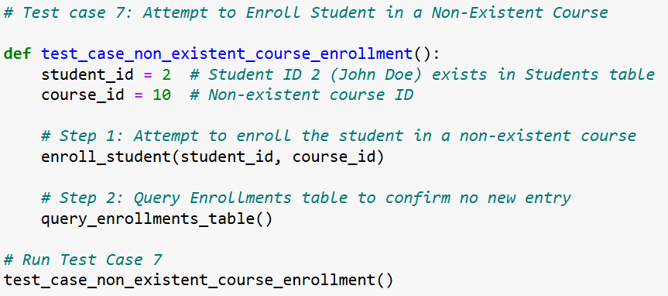**Output**:

1. Enrollment fails, and a message "Enrollment failed: Course ID 10 does not exist." is displayed. 
2. Enrollments table remains unchanged, with no entries for student_id = 2 and course_id = 10.